PowerSchool Verifying Grade Levels – DDE
Verifying Grade levels in Sections for Class Size Survey data – Use the following instructions to pull information from PowerSchool using DDE to help ensure none of the sections are missing their grade levels. If the grade level was missed it would default to 0 which indicates Kindergarten.

Instructions:
- On the PowerSchool start page, choose System from the main menu.
- Then choose Direct Database Export (DDE) from the list.
- For Current Table: choose Sections(3).
- Under Search Sections filter the Term ID >=(greater than or equal to) TermID
(the Term ID for 2013/2014 is 2300).
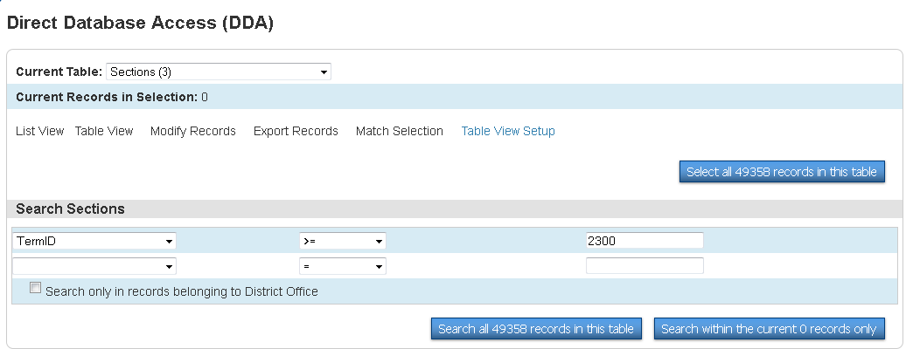

- Once you have all the above information in the screen then Search all #### records in this table.

- If your search is successful then you will notice the “0” in the Current Records in Selection change to the number of records you pulled in your search. Example below changed to 716 records found.
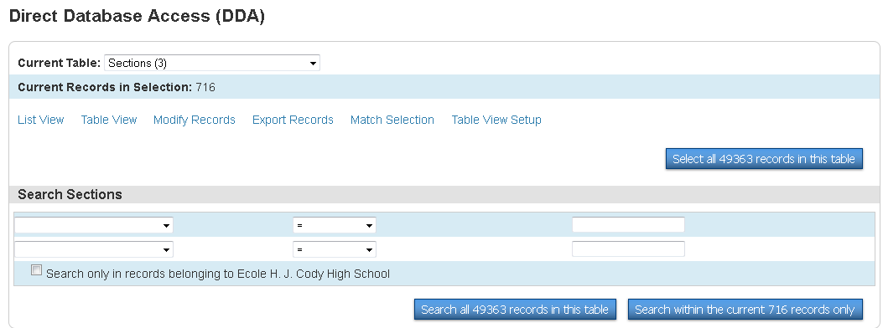

- Click - Export Records.

- On the next screen input the following information into the Field Delimiter area.
Course_Number
NOTE: If you have multiple grades in sections then you should have the AB_Sec_Multi_Grades filled in.
[2]Course_Name
Section_Number
Grade_Level
AB_Sec_Multi_Grades
[5]LastFirst

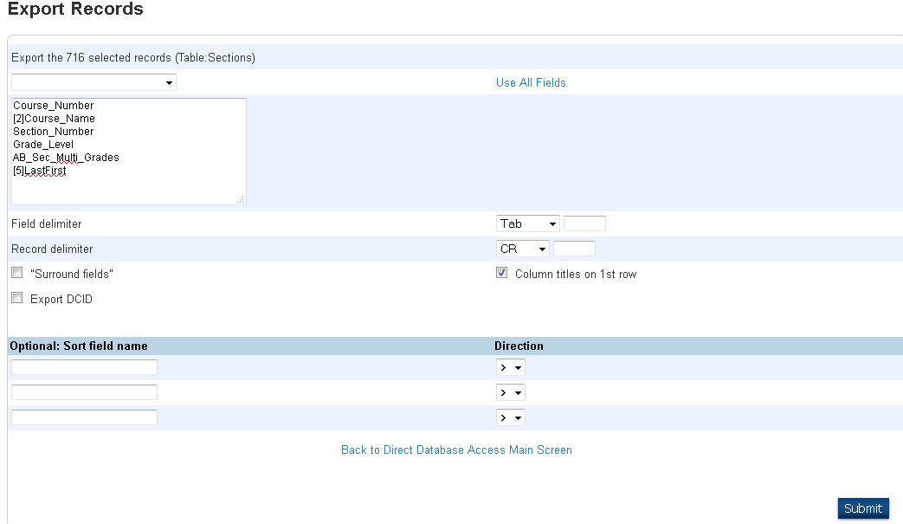

All of these fields can be found in this drop down menu, except for the ones pulling from other tables [ ], which will have to be typed in.

- Remember to click on SUBMIT.

- This information will now be pulled into EXCEL where it will be easy to see which sections are not set up with Grade Levels.

