PowerSchool Honour Roll Calculation – DDE
Honour Roll – Use the following instructions to pull information from PowerSchool using DDE to help calculate honour roll for your school.

Instructions:
- On the PowerSchool start page, choose System from the main menu.
- Then choose Direct Database Export (DDE) from the list.
- For Current Table: choose StoredGrades(31)
- Under Search StoredGrades, filter the term ID that you want to pull the stored grades for.
The example below is for Semester One.
TermID = 2201(S1)
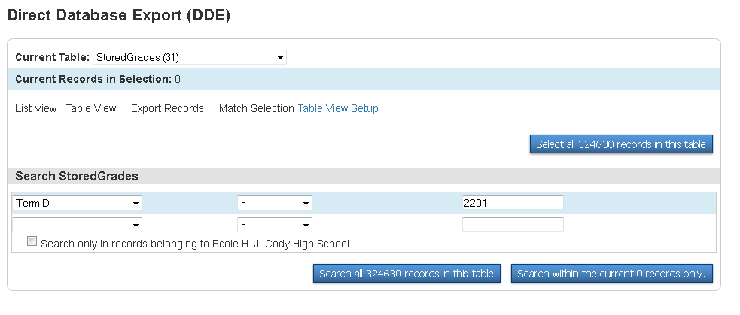

- Once you have all the above information in the screen then Search all #### records in this table

- If your search is successful then you will notice the “0” in the Current Records in Selection change to the number of grades it found to pull in your search. Example below changed to 7798 records found
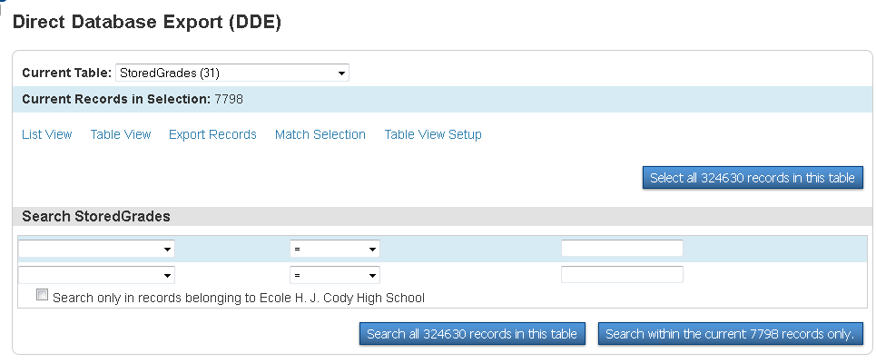

- Now that you have all the stored grades for S1 you will need to Export Records.

- On the next screen you will need to put the field and table information into the Field Delimiter area that you want to pull to get the information you need to calculate honour roll. Below are some examples you may want included, but can leave any out that you do not think you will need.
[1]lastfirst
Grade_Level
course_name
Teacher_Name
AB_Final_Mark (only for diploma courses after RCM files have been imported)
Grade
EarnedCrHrs

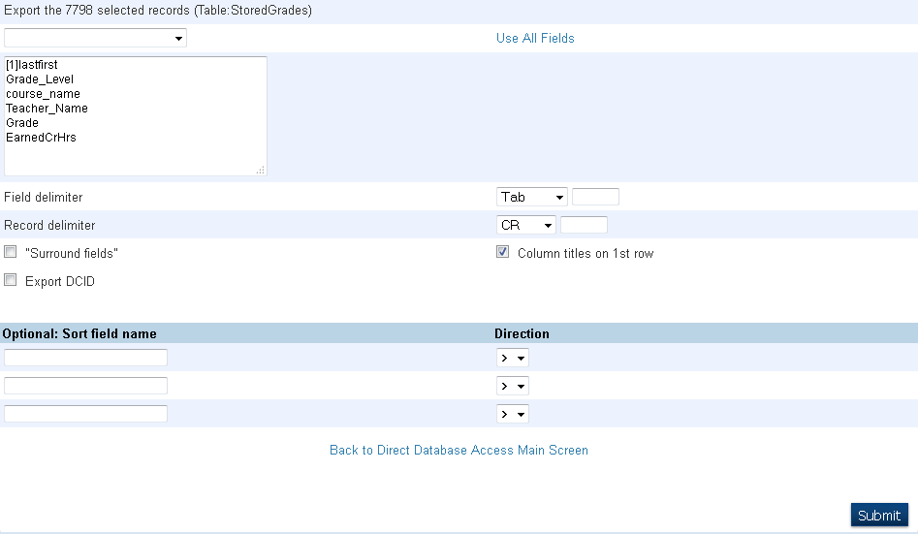
All of these fields can be found in this drop down menu, except for the [1]lastfirst, which will have to be typed in.

- Remember to click on SUBMIT

- This information will now be pulled into EXCEL where you can sort to help calculate honour roll.

Things to NOTE:
- You will have to do steps 4 – 10 for all terms that you want to include in your calculation.
- TermID = 2202(S2)
TermID = 2200(YearLong)
- TermIDs listed in these instructions are for the 12/13 School Year.
- Marks must be stored to pull
- Once you have your terms in separate Excel sheets, you can merge them together to make calculating easier.

